**Introduction:**

Form the development in game industry, through the first console game is came out over two decades. The requirements of users are increase sharply. In 2020, the global gaming industry’s revenue is over 165 billion USD, and the global players are over 2.7 billion. (Viswanath, 2021). As we can see from above, the game market is a very huge and competitive market. To attract the attention of players, game manufacturers around the world must constantly iterate their own game products to meet the need of players. Therefore, the frequent changes to existing requirements and constant iterations in the development process have led to a constant increase in the contradiction between developers and testers in game companies. This affects the speed of game iteration much lower than expect.

The advent of DevOps architecture has helped business managers solve the friction between developers and testers within their organizations. Make the speed of game iteration catch up with the needs of users. This article is intended to explain what DevOps is and how DevOps is used in the gaming industry.

**What is DevOps:**

By the definition of DevOps, it outlines the process of software development and the shift of organization culture. Use automating or integral tools to help developer and operations teams’ delivery a high quality software. (IBM, 2019). The outline of the DevOps process should show like below

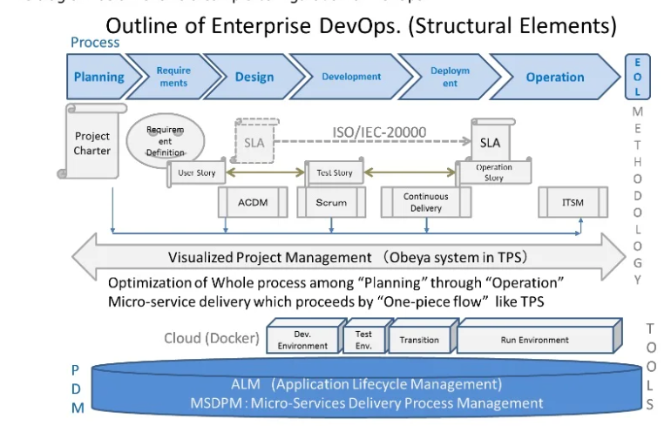

(Koichiro Toda, 2016)

**Why DevOps:**

In the past, when game company want to develop a game, the agile development method is the first choice. However, due to the requirement changes much normally than before. The many drawbacks of agile development method comes out and overshadow it’s benefits. Such as the agile development method is mainly focus on iterative development with the testing scheduled at the end of the process. That may cause some serious problem such as the game developed is not suit for all platform. (Jessica, 2021). There are several benefits for game companies to use DevOps in their game developing process:

1. Easy Resource Allocation:

Compared to the traditional agile development, DevOps can make sure the fully automatic allocate the task for project managers. Because the automation is the epicenter of DevOps.

1. Continuous Testing

Not like the traditional agile development, put the testing into the end of the develop cycle. DevOps provides a better testing scope to the development teams; DevOps allow the QA teams continue testing during the development period. That means bugs can eliminated at the early stage of the game development cycle.

During the develop process of games, QA teams work with the developer much closer. QA will test each module during developer’s developing to make sure the bug in new code will not affect the stable game environment.

1. Continuous Monitoring

Manual monitor the game code for a long term is impossible because the game code is extensive, and no one know which part will broke when new code upload. DevOps allows both QA and developers can use automate tools to track each module of the code, when the error happened, it is easily for developer to find the solution and solve the bug as soon as possible.

1. Enhanced Usability

As we mentioned before, the game industry needs to be customer centric. Put the player’s needs first. As the result, the frequent change needs of game designer often occur in game development. Because they don’t always understand what player’s real needs are. DevOps gives game designer this chance by response to customer feedback more quickly to catch what is their customer real need. (Jessica, 2021).

1. Fast Release:

DevOps has another feature is to help bring innovative products to market faster, as we mentioned before, this is the main challenge in game industry. It allows game developers continuing develop new version of the game and integrate to the main stream.

**The Architecture of DevOps Teams:**

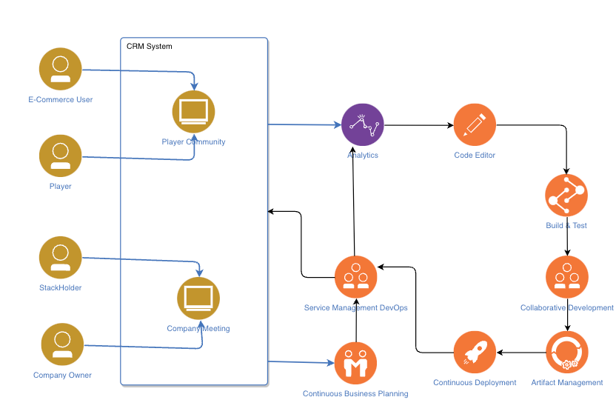

The architecture of DevOps is shown in the figure above. The CRM system is a way to connect with user needs and user feedback. Users include gamers, company owners, and stakeholders. Feedback from gamers comes mainly from the community of gamers founded by free companies. Feedback from the company's owner and stakeholders comes from within the enterprise and determines the development and direction of the enterprise. The information is analyzed by the game development department through the CRM system, and after the release plan, it is submitted to the development department to be developed together with the test department. During the development the game developer and the tester will work closely and release several small modules. These modules will be combined into the main application if they pass the test and make sure it will not crash the main game.

**Downside Of DevOps in game industry:**

Although DevOps is theoretically a very perfect system. But, it is not perfect. There are still many problems in many specific implementations. Such as it is hard to organized and controlled, developer fatigue and user fatigue.

Organized:

DevOps enables developers and testers to focus all their efforts on functional iterations, but for DevOps, a system that evolved from agile development. The need for development documentation is not well normalized in DevOps. In theory, developing documentation is not a very important thing. But in reality for a company. Attrition and alternation is a normal phenomenon. The lack of specifications on the development documentation makes it very difficult to rotate positions. New employees don't take over the jobs of older employees very well. This leads to a reduction in development efficiency and a delay in the project. (Viswanath, 2021)

Develop fatigue:

Quickly iteration is the advantage of DevOps. However, it is also a disadvantage in real life. Because rapid iteration requires a lot of labor costs. Developers and testers have to stay in their jobs for long periods of time. So for companies they only have two options: 1. Recruit more developers and testers to rotate 2. Increase the on-the-job time of the same group of developers. The first option is a viable solution for large companies and not a good solution for small companies. Because there is too much labor cost to be invested. The second option is the only solution for small companies, but the need for long hours of overtime can lead to developers refusing to work overtime or even strike. (Philippe, 2018)

User fatigue:

Fast iteration is also a very unfriendly thing for users. Because whenever users are exposed to something new they need a certain amount of time to digest and become familiar with new things. Rapid iterations that force users to constantly try new things can lead to user fatigue. (Philippe, 2018)

Reference:

IBM. (2019, October 2). *Devops*. Www.ibm.com. https://www.ibm.com/cloud/learn/devops-a-complete-guide

Jessica. (2021, September 24). *Importance of DevOps in Mobile Game Development: A Detailed Insight*. EuroStar Huddle. <https://huddle.eurostarsoftwaretesting.com/importance-of-devops-in-mobile-game-development-a-detailed-insight/>

Koichiro Toda. (2016, September 7). *success with enterprise dev-ops - whitepaper -*. https://www.slideshare.net/KoichiroToda/success-with-enterprise-devops-whitepaper

Philippe, L. (2018, November 12). *Downsides of DevOps*. Scrum.org. https://www.scrum.org/resources/blog/downsides-devops

Viswanath, K. (2021, August 5). *How Can DevOps Optimise The Game Development Process?* BW Businessworld. https://www.businessworld.in/article/How-Can-DevOps-Optimise-The-Game-Development-Process-/05-08-2021-399433/